# Planning of Project

To organize the distribution of tasks and to meet deadlines of the project, we decided to use Scrum, an agile framework for managing the work. The idea of Scrum is to divide the project in a list of actions (backlog) that can be completed within time boxed iterations (sprints). Because of small time of all project, the sprints intervals are at maximum one week, and the daily scrums occurs before or after some normal class.

The tools chosen to assist in the execution of the scrum and in the follow-up of the project execution were Trello and TeamGantt. The Gantt graph is shown in the next topics.

To facilitate the exchange of information between the team, a group was created in chat tool. And the code is shared in github.

The project was divided in some groups, to evidence the deadlines of sub products and the application. Each group has some tasks, that could be linked to sub product. The following figures shows this groups, estimated time and deadline. The tasks will be chosen freely by team members, and dynamically allocated.

These initial tasks are just to estimate the functions we can add in the application, considering the deadline, number of team member and experience of team in the chosen technology. After define the additional functionalities, the backlog will be filled by the new tasks.

The second column in the Gantt figures shows the percentage of the execution of the product.

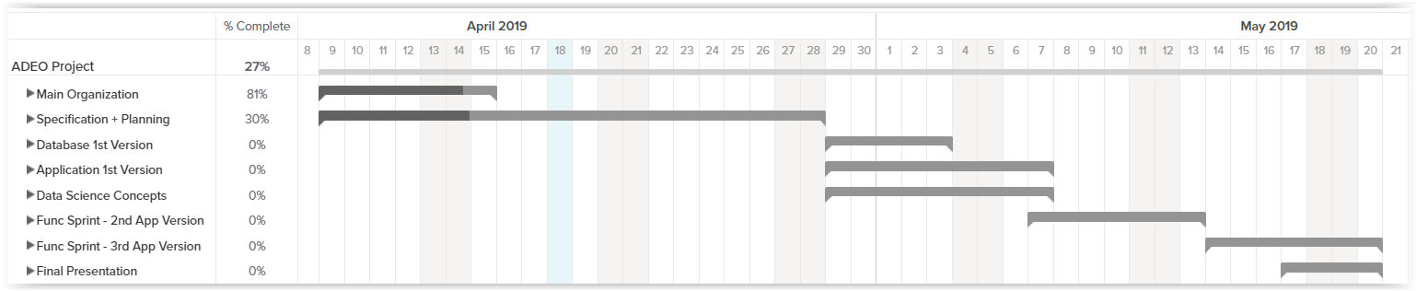

**Figure 1.** Gantt for all project

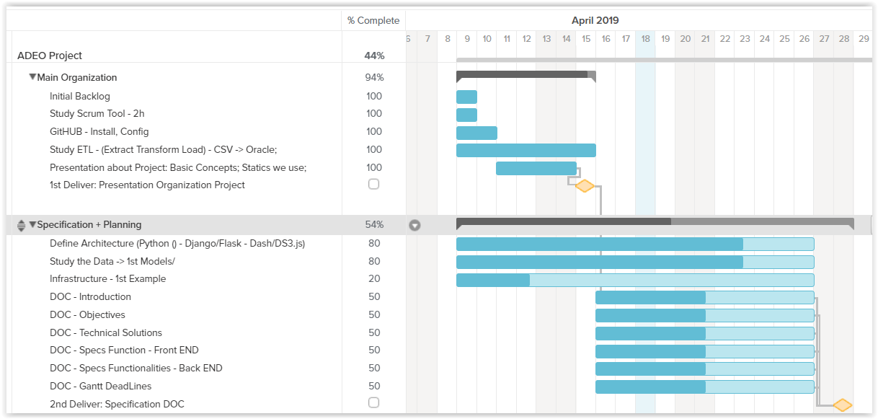

**Figure 2**. Tasks for Main Organization and Specification-Planning

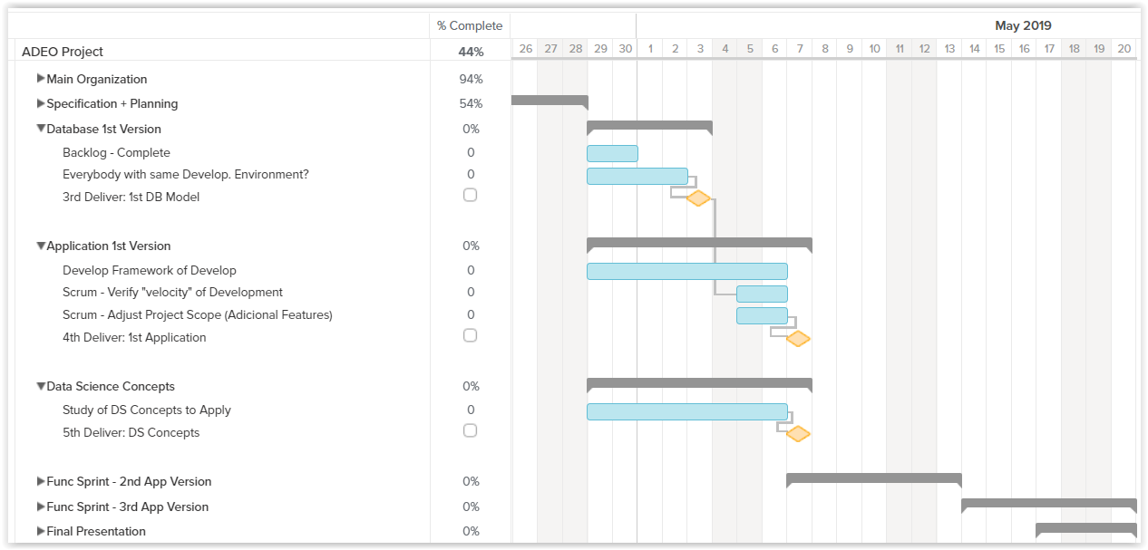

**Figure 3**. Tasks for “Database 1st Version”, “Application 1st Version”, “Data Science Concepts”, “Functional Sprints” and “Final Presentation”.